East Falls Historical Society

Join us for

“East Falls: An Historical Overview”
An illustrated zoom lecture
presented by
Steven J. Peitzman

Wednesday, February 15, 2023 at 6:30pm

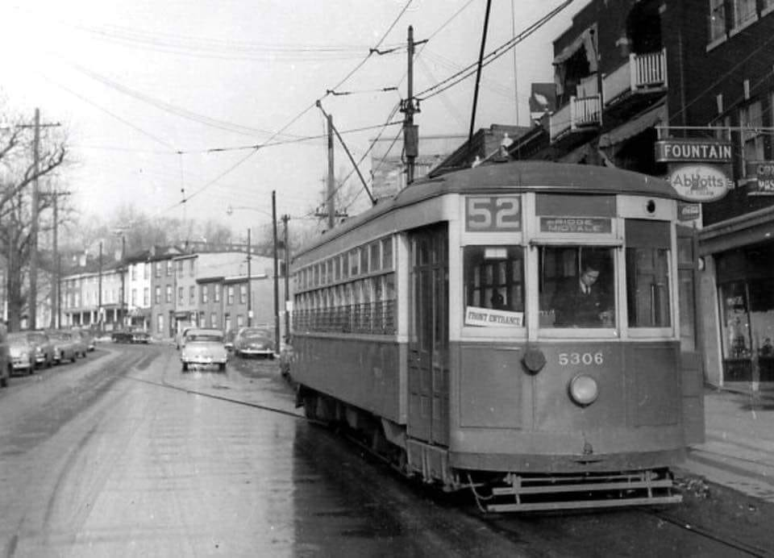

Zoom link will be sent to members and posted on www.eastfallshistoricalsociety.org on February 14.

Inquiries? eastfallshistory@gmail.com
Visit us on Facebook!

